Suplementary Material

Long-term changes in population dynamics and life history contribute to explain the resilience of a stock of *Micropogonias furnieri* (Sciaenidae, Teleostei) in the SW Atlantic.

**Authors**

Manuel Haimovici1, Leticia Maria Cavole2, Jason M. Cope³, Luís Gustavo Cardoso1

3.2 Changes at first maturity

Here we present the estimated values for parameters of the fitted logistic model by sex (Tables 1 and 2). The Figures 1 and 2 shows the trace plots of the evolution of the parameter vectors over the iterations of the three Markov chains and the respective the parameters posterior distributions. The Figure 3 show the posterior distribution of the estimated age at first maturity.

Table 1. The posterior parameters for the logistic model (*beta0 and beta 1*) estimated for females of *Micropogonias furnieri* from southern Brazil Sd= standard deviation. Overlap0 checks if 0 falls in the parameter's 95% credible interval. *f* is the proportion of the posterior with the same sign as the mean; i.e., our confidence that the parameter is positive or negative.. Successful convergence based on Rhat values (all < 1.1). Rhat is the potential scale reduction factor (at convergence, Rhat=1). For each parameter, n.eff is a crude measure of effective sample size.

|  |  |  |  |  |  |  |  |  |  |
| --- | --- | --- | --- | --- | --- | --- | --- | --- | --- |
| Parameters | mean | sd | 2.50% | 50% | 97.50% | overlap0 | f | Rhat | n.eff |
| beta0 | -10.183 | 0.917 | -12.094 | -10.161 | -8.488 | FALSE | 1 | 1.006 | 933 |
| beta1 | 0.028 | 0.002 | 0.024 | 0.028 | 0.033 | FALSE | 1 | 1.006 | 927 |
| deviance | 53.917 | 2.008 | 51.972 | 53.295 | 59.474 | FALSE | 1 | 1.005 | 506 |

Table 2. The posterior parameters for the logistic model (*beta0 and beta 1*) estimated for males of *Micropogonias furnieri* from southern Brazil Sd= standard deviation. Overlap0 checks if 0 falls in the parameter's 95% credible interval. *f* is the proportion of the posterior with the same sign as the mean; i.e., our confidence that the parameter is positive or negative.. Successful convergence based on Rhat values (all < 1.1). Rhat is the potential scale reduction factor (at convergence, Rhat=1). For each parameter, n.eff is a crude measure of effective sample size.

|  |  |  |  |  |  |  |  |  |  |
| --- | --- | --- | --- | --- | --- | --- | --- | --- | --- |
| Parameters | mean | sd | 2.50% | 50% | 97.50% | overlap0 | f | Rhat | n.eff |
| beta0 | -9.251 | 0.925 | -11.132 | -9.228 | -7.486 | FALSE | 1 | 1.009 | 357 |
| beta1 | 0.029 | 0.003 | 0.024 | 0.029 | 0.035 | FALSE | 1 | 1.009 | 358 |
| deviance | 78.03 | 1.979 | 76.068 | 77.43 | 83.34 | FALSE | 1 | 1.009 | 573 |

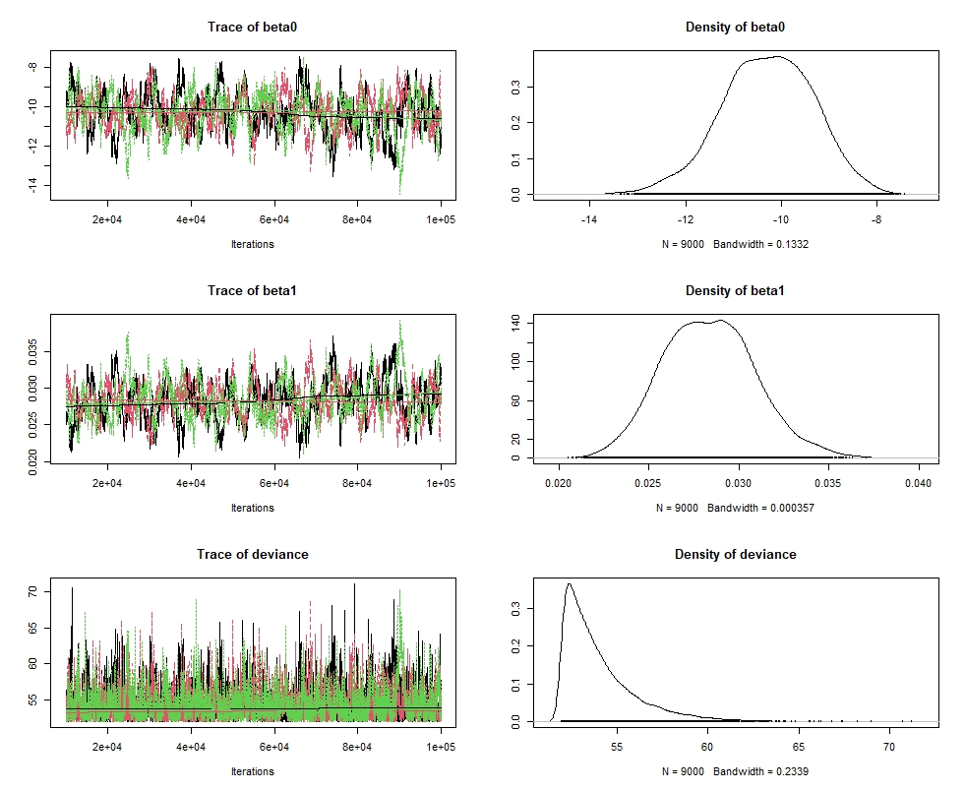

Figure 1. Females MCMC diagnostic plots for the logistic parameters fitted to pooled maturity at length data and its respective posterior distributions.



Figure 2. Males MCMC diagnostic plots for the logistic parameters fitted to pooled maturity at length data and its respective posterior distributions.

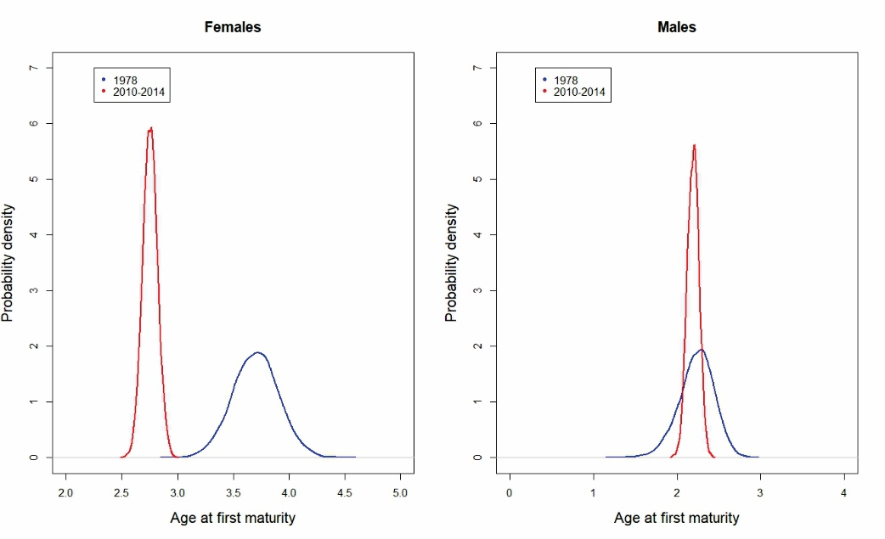

Figure 3. Posterior distributions of age at first maturity for females and males computed for the first and the last period with estimated growth parameters.